

American International University-Bangladesh (AIUB) Department of Computer Science

Faculty of Science &Technology (FST) Summer 21 22

Section: F

Software Quality Assurance and Testing

Bikroy.COM

**Group-10**

A Report submitted

By

|  |  |  |
| --- | --- | --- |
| **SN** | **Student Name** | **Student ID** |
| 1 | Deb, Oscar | 20-42888-1 |
| 2 | RAHIM, NEAMUL IBNE MONIR | 19-41704-3 |
| 3 | DAS, ATUNA | 20-42914-1 |
| 4 | PAUL, TOMAL | 20-42123-1 |

Under the supervision of

**ISRAT JAHAN MOURI**

**Faculty Member**

Software Test Plan

for

Bikroy.com

Version 1.0 approved

**Prepared by,**

1. Deb, Oscar
2. RAHIM, NEAMUL IBNE MONIR
3. DAS, ATUNA
4. PAUL, TOMAL

American International University-Bangladesh (AIUB)

**25-Aug-2022**

**Checked By Industry Personnel**

Name:

Designation:

Company:

Sign:

Date:

Table of Contents

Revision History 3

1. TEST PLAN IDENTIFIER: RS-MTP01.3 3

2. REFERENCES 3

3. INTRODUCTION 3

Background to the Problem 3

Solution to the Problem 4

4. REQUEIREMNT SPECIFICATION 4

4.1 System Features 4

4.2 System Quality Attributes 4

4.3 System Interface 5

4.4 Project Requirements 5

5. FEATURES NOT TO BE TESTED 5

6. TESTING APPROACH 5

6.1 Testing Levels 5

6.2 Test Tools 6

6.3 Meetings 6

7. TEST CASES/TEST ITEMS 6

8. ITEM PASS/FAIL CRITERIA 7

9. TEST DELIVERABLES 7

10. STAFFING AND TRAINING NEEDS 8

11. RESPONSIBILITIES 8

12. TESTING SCHEDULE 8

13. PLANNING RISKS AND CONTINGENCIES 9

14. APROVALS 9

# Revision History

|  |  |  |  |
| --- | --- | --- | --- |
| **Revision** | **Date** | **Updated by** | **Update Comments** |
| 0.1 | 2022.12.1 | Oscar Dev | First Draft |
| 0.2 | 2022.12.5 | Atuna Das | Second Draft |
| 0.3 | 2022.12.7 | Oscar Dev | Third Draft |
| 0.4 | 2022.12.12 | Neamul Rahim | Forth Draft |
| 0.5 | 2022.12.24 | Tomal Paul | Fifth Draft |

# 1. TEST PLAN IDENTIFIER: Bikroy.com

# 2. REFERENCES

1. <https://bikroy.com/>
2. [What is Postman Automation? - GeeksforGeeks](https://www.geeksforgeeks.org/what-is-postman-automation/?msclkid=d6e6137bc00311ecbd51cacea19a9553#:~:text=Postman%20is%20a%20cutting-edge%20Automation%20tool%2C%20which%20can,Postman%20Runner%20functionality%20this%20feature%20can%20be%20used.)
3. <https://www.postman.com/automated-testing/>
4. <https://bnblog.bikroy.com/?_gl=1%2Avbgh63%2A_ga%2ANzk0NTcyNTE2LjE2Njk3NDMxNjA.%2A_ga_LV7HJQBLZX%2AMTY3MTk5NjgxNy4xMi4xLjE2NzE5OTY4MzQuNDMuMC4w>
5. <https://www.blazemeter.com/blog/chrome-extension-selenium>

# 3. INTRODUCTION

## 3.1 Background to the Problem

In our daily life sometimes, we need to buy what we need or sell products for money instantly. But without advertisement we can’t do that properly. Sometimes we are searching for the best deals and different product options .But in generally this is not possible. In that time we doesn’t get any proper solution

## 3.2 Solution to the Problem

Here the main goal of Bikroy.com to make peoples life easy. You don’t have to out side to buy and sell your used or unused products. You can simply signup an account and search for the product you want to buy from the huge list or sell the product by creating advertisement with proper details by staying in your home and get the best deals.

# 4. REQUEIREMNT SPECIFICATION

## System Features

## 4.1 Sign Up:

**Functional Requirements**

1. System allows new user to get sign up to the system.
2. User have to provide their first name, last name, email, phone number and reason for choosing us
3. A verification code will be sent to the user email or phone number to verify their ID.
4. If verification is successful than they are registered to the system, if not verified then verification code is sent again.

**Priority level:** High.

**Precondition:** User have valid email address.

## 4.2 Login:

**Functional Requirements**

1. If user is already registered to the system, then he/she can directly login to the system by providing his/her email or phone number and password.
2. If by mistakenly email/phone number or password is wrong more than 3 times then system will not allow to login to the system and will send verification code to the user to reset the account.

**Priority level:** High.

**Precondition:** User have valid student id and password.

## 4.3 : Database Job Search

**Functional Requirements**

First Go to the website. Then enter My Account. Next step is Enter Profile Database. After that Click Search for searching the products

**Priority level:** High.

**Precondition:** User logged in and provided correct product name or category

## 4.4 Profile Database Shortlist  :

**Functional Requirements**

Go to the website first. Then Enter Post Ad. After that enter Profile Database for searching . Then search and click the Shortlist.

**Priority level:** High.

**Precondition:** User must have valid username and password

## 4.5 Report_Duplicate_Ads:

**Functional Requirements**

Go to the website first.Then select Any category. Click “Report this ad” for report. Enter Description of it .In the end Click Send.

**Priority level**: High.

**Precondition:** No need any precondition

## 4.6 Check Link Validation:

**Functional Requirements**

Go to website first. Then click any random links

**Priority level**: Medium.

**Precondition:** User must have to click some random links.

## 4.7 Post Ad:

**Functional Requirements**

Go to the website. If you give invalid numbe the Invalid Number won’t be accepted. Enter the

Valid Phone Number. Then Enter OTP.

**Priority level:** High

**Precondition:** User must be Enter their valid phone number

## 4.8 Number Verification  :

Functional Requirements

Login to the website .Click ‘MyAccount’ .Go to settings.

Enter ‘name’, ‘location’, and’Sub-location’. Click ‘Update Details.

**Priority level:** High

**Precondition:** User Information is verified. Edit profile has been done successfully.

## 4.9 Update Profile :

Functional Requirements

Login to the website. Then Click on the search placeholder and search random things

**Priority level:** High

**Precondition:** User can see the searched things.

## 4.10 Message Sending Feature:

**Functional Requirements**

Login to the website.Searching things and going into detail about that thing.Here, one can chat with the owner.Media items like pictures, videos, or messages can be sent to them.

**Priority level:** High

**Precondition**: User can communicate with owner by sending media items

# 4.11. Payment Module (Online)

**Functional Requirements**

This Test case is for testing the Payment Module (online)

**7.13  Payment Module (COD**)

**Functional Requirements**

Go to the website and select Doorstep Delivery.Click Explore and select a Product.Click Order Online.Enter Personal Information and continue.Select Cash on delivery and continue. Enter OTP and click Confirm.

**Priority level:** High

**Precondition**: User should get the verification code and confirm it and get the order confirmation message in his mobile.

# 6. TESTING APPROACH

* **Unit Testing:**
* **Integration Testing:**
* **System Testing:**
* **Acceptance Testing:**

## 6.1 Testing Levels

* **SYSTEM/INTEGRATION** Testing is performed by the test manager and development team leader with assistance from the individual developers PRN. Programs will enter into System/Integration test finally critical defects are corrected. there's a bit around for the error.

* **UNIT TESTING** is done by the developer, then the results are visiting be authorized by the team lead. Before unit testing is additionally accepted and passed on to the test person, the programmer must submit proof of unit testing (test case list, sample output, data printouts, defect information). The test person will receive all unit test information moreover.

* **ACCEPTANCE** The customer will doACCEPTANCE testing with the assistance of the test manager and development team leader. After the System/Integration test is completed, the acceptance test will run in parallel with the prevailing manual process for two weeks.

## 6.2 Test Tools

Here, for the testing purpose Postman, a solid testing tool was used to test the connection from code to the browser. Since Postman is easy to use and update things from the database, the executed results were right and also not so time consuming. Using Postman, the test results were seen quicker than the browser itself.

 **Postman- Testing tool**

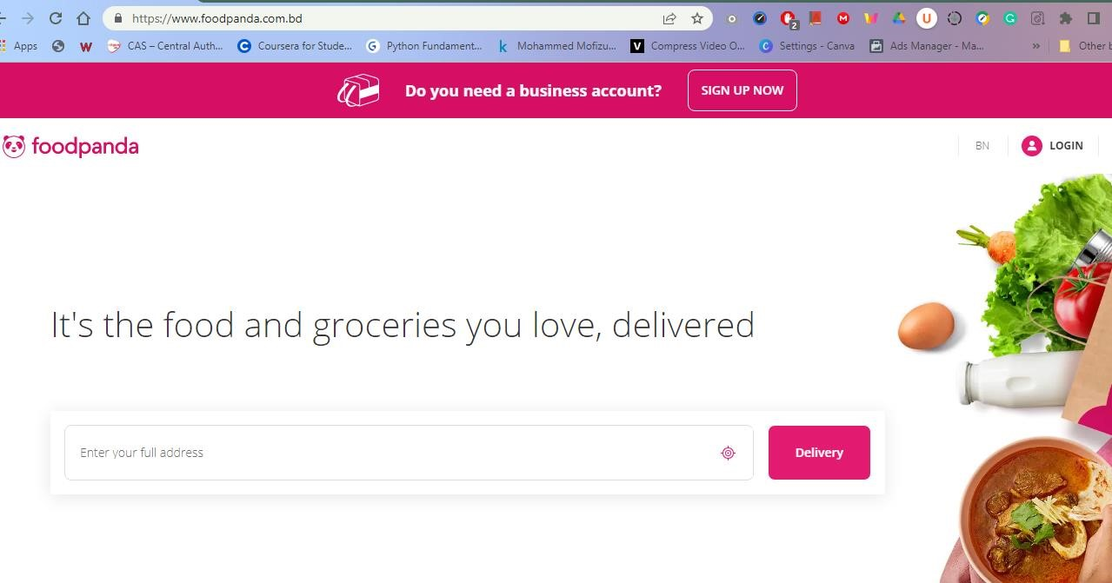

*Fig.01: Food Panda Open in Chrome Browser*

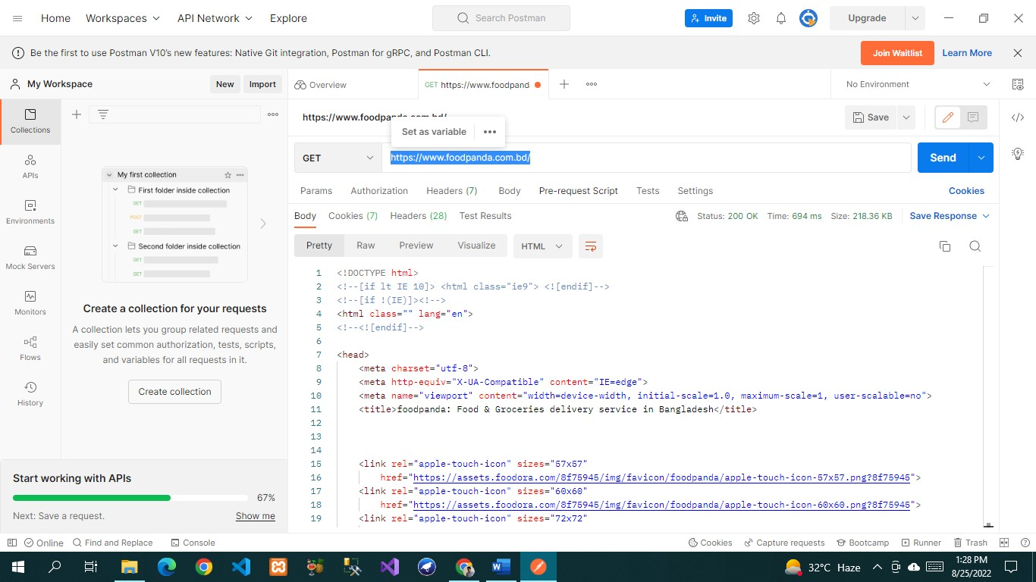

*Fig.02: Food Panda tested connectivity on Postman testing tool*

## 6.3 Meetings:

This entire project duration is 1 weeks. Every day our group member was met to discuss about project advancements and every group member suggestion for improving functionality.

Additional meetings were called as needed for emergency situations.

# 7. TEST CASES/TEST ITEMS (Food Panda)

**7.1** **Sign Up:**

This Test case is for testing the sign-up details

|  |  |  |  |  |
| --- | --- | --- | --- | --- |
| Project Name: Smart Canteen of AIUB | | | Test Designed by: Mahja Bin khondokar | |
| Test Case ID: FP_01 | | | Test Designed date: 24 August, 2022 | |
| Test Priority (Low, Medium, High): High | | | Test Executed by: Mahja Bin khondokar | |
| Module Name: Sign Up | | | Test Execution date: 24  August, 2022 | |
| Test Title: Verify sign up sending verification code | | |  | |
| Description: Test the sign-up verification | | |  | |
| Precondition: User should have valid email or phone number | | |  | |
| Test Steps | Test Data | Expected Results | Actual Results | Status  (Pass/Fail) |
| 1. Go to the website sign up page 2. Enter first name 3. Enter last name 4. Enter valid email 5. Enter valid phone number 6. Select reason for choosing us 7. Click sign up | First Name: Mahjabin    Last Name:  Khondokar    Email:  mahjabin@gmail.com    Phone no:0125478965 | Verification code should be sent to the user email or phone no | As expected, | Pass |
| Post Condition: User should get the verification code and confirm it and get sign up in to the system successfully. | | |  | |

## 7.2 Login:

This Test case tests the login that a student can login using their id and password

|  |  |  |  |  |
| --- | --- | --- | --- | --- |
| Project Name: Food Panda | | | Test Designed by: Mahja Bin khondokar | |
| Test Case ID: FP_02 | | | Test Designed date: 21 August, 2022 | |
| Test Priority (Low, Medium, High): High | | | Test Executed by: Mahja Bin khondokar | |
| Module Name: Login | | | Test Execution date: 21 August, 2022 | |
| Test Title: Verify login with valid email or phone number and password | | |  | |
| Description: Test the system login | | |  | |
| Precondition: User should have registered mail address/phone number and password | | |  | |
| Test Steps | Test Data | Expected Results | Actual Results | Status  (Pass/Fail) |
| 1. Go to the login page 2. Enter valid email/ phone number 3. Enter password  4. Click login | Email:  mahjabin@gmail.com  or  Phone:0125478965    password: 123 | User should login to the system | As expected, | Pass |
| Post Condition: User should have logged in to the system successfully | | |  | |

## 7.3 View Food List

This Test case will check that the feature is showing all the product with their corresponding details or not

|  |  |  |  |  |
| --- | --- | --- | --- | --- |
| Project Name: Food Panda | | | Test Designed by: Most. Kaniz Ayesha | |
| Test Case ID: FP_03 | | | Test Designed date: 21 August, 2022 | |
| Test Priority (Low, Medium, High): High | | | Test Executed by: Most. Kaniz Ayesha | |
| Module Name: View Food List | | | Test Execution date: 21 August, 2022 | |
| Test Title: Showing all the product with their corresponding details | | |  | |
| Description: Test all the products are visible or not | | |  | |
| Precondition: Login | | |  | |
| Test Steps | Test Data | Expected Results | Actual Results | Status  (Pass/Fail) |
| 1. Go to the website in Food Panda 2. Login to the page 3. Go to the Food page |  | User should see all the food items in  details with the price | As expected, | Pass |
| Post Condition: | | |  | |

## 7.4 Add to Cart

This Test case is for checking the user whether he/she can order multiple food items.

|  |  |  |  |  |
| --- | --- | --- | --- | --- |
| Project Name: Food Panda | | | Test Designed by: Anindita  Biswas Ani | |
| Test Case ID: FP_04 | | | Test Designed date: 19 August, 2022 | |
| Test Priority (Low, Medium, High): High | | | Test Executed by: Anindita  Biswas Ani | |
| Module Name: Add to cart | | | Test Execution date: 19 August, 2022 | |
| Test Title: Adding items in the cart | | |  | |
| Description: Test whether multiple items are added in the cart | | |  | |
| Precondition (If any): Select more than one items from the food items | | |  | |
| Test Steps | Test Data | Expected Results | Actual Results | Status  (Pass/Fail) |
| 1. Go to the Food Panda page. 2. Select multiple food items. |  | User should see all the selected items on cart. | As expected, | Pass |
| Post Condition: | | |  | |

## 7.5 Payment Method

This Test case tests the payment method. There is used two types of payment method. Users can either pay with cash or using mobile banking named Bkash.

|  |  |  |  |  |
| --- | --- | --- | --- | --- |
| Project Name: Food Panda | | | Test Designed by: Mahja Bin khondokar | |
| Test Case ID: FP_05 | | | Test Designed date: 22 August, 2022 | |
| Test Priority (Low, Medium, High): High | | | Test Executed by: Mahja Bin khondokar | |
| Module Name: Cash Payment Method | | | Test Execution date: 22 August, 2022 | |
| Test Title: Showing options for paying with cash | | |  | |
| Description: Test Bkash cash validation | | |  |  |
| Precondition (If any): Items should be added to the cart. | | |  |  |
| Test Steps | Test Data | Expected Results | Actual Results | Status  (Pass/Fail) |
| 1. Add 1 burger and 1 coke 2. Pay with Bkash. | Pay 145 BDT by Bkash | The system must  accept cash 145 BDT | As expected, | Pass |
| Post Condition: | | |  |  |

## 7.6 Menu

This Test case is for checking the user whether he/she can show all menu option

|  |  |  |  |  |
| --- | --- | --- | --- | --- |
| Project Name: Food Panda | |  | Test Designed by: Mahja Bin khondokar | |
| Test Case ID: FP_06 | |  | Test Designed date: 24 August, 2022 | |
| Test Priority (Low, Medium, High): Medium | |  | Test Executed by: Mahja Bin khondokar | |
| Module Name: Menu | |  | Test Execution date: 24, August, 2022 | |
| Test Title: Showing menu option | |  |  | |
| Description: Test all the menu option | |  |  | |
| Precondition (If any): Login | |  |  | |
| Test Steps | Test Data | Expected Results | Actual Results | Status  (Pass/Fail) |
| 1. Go to the website page 2. Login to the page 3. Go to menu option |  | In menu User can find many options like setting, profile, vouchers, help center, privacy, logout | As expected, | Pass |
| Post Condition: | |  |  | |

## 7.7 Settings:

The test case is for the settings options

|  |  |  |  |  |
| --- | --- | --- | --- | --- |
| Project Name: Food Panda | | | Test Designed by: Rabeya Akter Ripa | |
| Test Case ID: FP_07 | | | Test Designed date: 23 August, | |
|  | | | 2022 | |
| Test Priority (Low, Medium, High): Low | | | Test Executed by: Rabeya Akter Ripa | |
| Module Name: Settings | | | Test Execution date: 23 August, 2022 | |
| Test Title: Test all the settings option | | |  | |
| Description: Test all the orders are visible or not | | |  | |
| Precondition: User have logged in and went to system menu | | |  | |
| Test Steps | Test Data | Expected Results | Actual Results | Status  (Pass/Fail) |
| 1. Go to Food Panda page 2. Login to the page 3. Go to menu bar 4. Then from menu option click setting   option | . | In setting section user can change the language, floating icon, receive push notifications, receive offers by email | As expected, | Fail |
| Post Condition: | | |  | |

## 7.8 Change Password

This Test case is for Change password

|  |  |  |  |  |
| --- | --- | --- | --- | --- |
| Project Name: Food Panda | | | Test Designed by: Mahja Bin khondokar | |
| Test Case ID: FP_08 | | | Test Designed date: 24 August, 2022 | |
| Test Priority (Low, Medium, High): Medium | | | Test Executed by: Mahja Bin khondokar | |
| Module Name: Change password | | | Test Execution date: 24 August, 2022 | |
| Test Title: Test the changing password | | |  | |
| Description: Test the password is changing or not | | |  | |
| Precondition: Student have to logged into the system then went to system menu after that go to profile option | | |  | |
| Test Steps | Test Data | Expected Results | Actual Results | Status  (Pass/Fail) |
| 1. Login to the website 2. Go to menu option 3. Then from menu | Password: 45897 | Password should be added by the user and stored in database. | As expected, | Pass |
| option go to profile option |  |  |  |  |
| Post Condition: Database should be updated password | | |  | |

## 7.9 Update Profile:

This Test case is for update the profile

|  |  |  |  |  |
| --- | --- | --- | --- | --- |
| Project Name: Food Panda | | | Test Designed by: Mahja Bin Khondokar | |
| Test Case ID: FP_09 | | | Test Designed date: 24  August, 2022 | |
| Test Priority (Low, Medium, High): Low | | | Test Executed by: Mahja Bin Khondokar | |
| Module Name: Update Profile | | | Test Execution date: 24  August, 2022 | |
| Test Title: Test the update profile | | |  | |
| Description: Test the profile is update or not | | |  | |
| **Precondition:** User have logged in and went to system menu | | |  | |
| Test Steps | Test Data | Expected Results | Actual Results | Status  (Pass/Fail) |
| 1. Login to the website 2. Go to menu option 3. Click profile   option | Email:  mahjabin@gmail.com First Name: Mahjabin  Last Name: Khondokar  Phone No: 0124578954 | User provide information email and phone number should be verified and User edit their name and click save it will show that the profile is update | As expected, | Pass |
| Post Condition: After changing their name email, phone number profile show is update | | |  | |

# 8. ITEM PASS/FAIL CRITERIA

Total 8 test cases were implemented for the Food Panda. Firstly, when applied the test case to system at the unit testing, 95% of the test cases were passed successfully. But unfortunately, 5% were failed. The test cases were failing due to some query related issues on the database. When the test cases were applied after solving query related problem, all the test cases were successfully executed and thus passed the test.

# 9. TEST DELIVERABLES

* Test plan
* Test results documents
* Test summary
* Defect reports and summaries

# 10. TESTING SCHEDULE

Time has been allocated within the project plan for the following testing activities.

|  |  |  |
| --- | --- | --- |
| **Task Name** | **Duration** | **Responsible** |
| Requirement Analysis | 4 days | Project Manager |
| Design | 8 days | Project Manager |
| Writing codes | 22 days | Developers |
| Unit Test | 20 days | Developers |
| Documentation | 11 days | Test Engineer |

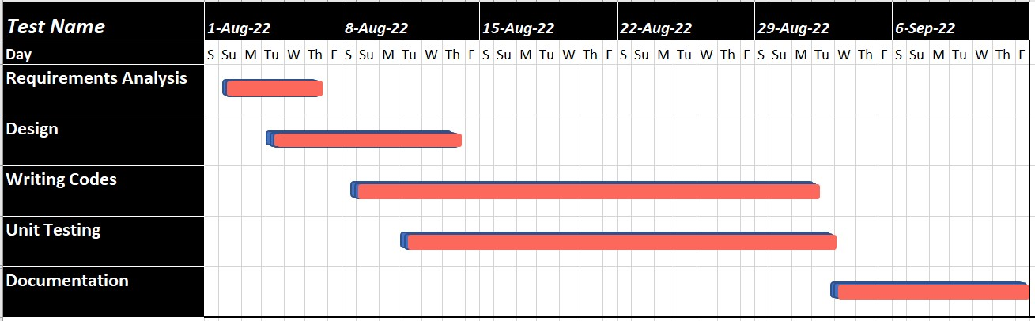

Fig.08: Test Schedule

# 11. PLANNING RISKS AND CONTINGENCIES

Since both the hardware and the software have to work together, This Food Panda may costly and the maintenance can be a hassle. Person to person interaction is very limited. Since it is selfservice system, the user must be careful during the selection of food items.